2. The assertions in between and at the end:

i. Opening the browser

ii. Navigating to the required or desired URL.

iii. Set text (email) in the required field.

iv. Set encrypted password.

v. Add validation (verify element present)

vi. Closing the browser after the task ends.

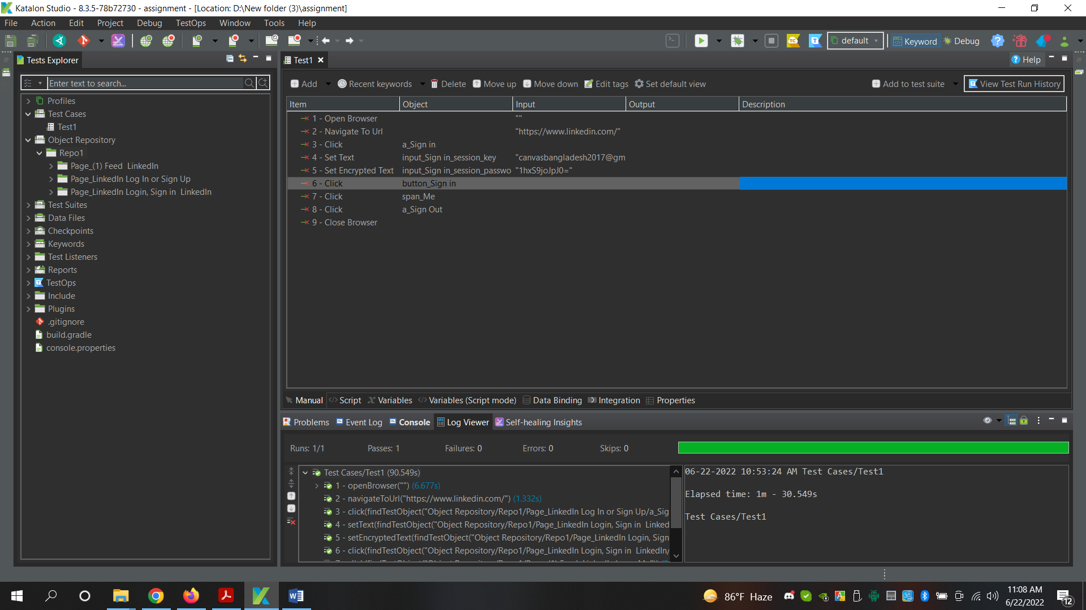

3. Best Practice to identify DOM element:

i. Finding element through class name.

ii. Finding from inspect element.

iii. Finding the DOM using element id.

Yes, DOM is implemented in LinkedIn pages. Since it’s important to need xpath for testing, DOM is implemented in LinkedIn pages.